**Instructions for participants:**

In this study, you will make reaching movements to targets presented on a screen

You must begin reaching to the target at the time the ring reaches the center of the screen.

Remain ahead of the ring as it expands outward.

On some trials, a cue will indicate the location of the target well in advance of your reach.

Please memorize the target associated with each cue.

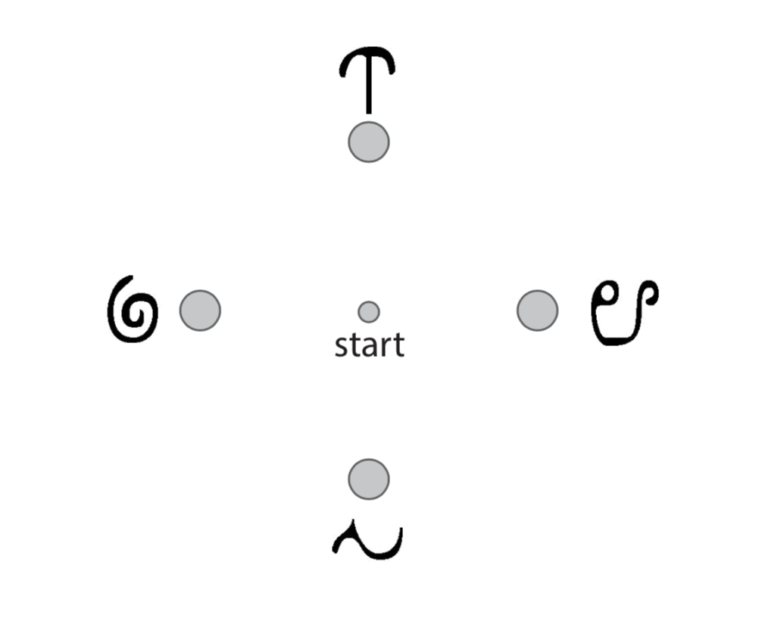

In this experiment, you will make reaching movements to targets presented on a computer screen while you lie in an MRI scanner. During the study, we will use the MRI scanner to take images of your brain. We will use these images to infer the neural activity occurring in your brain while you plan each movement. It is important that you remain completely still throughout the study, except for the small reaching movements that you will be making with your arm.

The task will require you to make reaching movements from a target located in the center of a screen to one of four possible target locations in the periphery of the screen. The experiment is divided into trials, and each trial will begin when your index finger is placed in the center of the screen. A small white circle marks the center of the screen, and every trial will begin when your index finger is on this start position.

After you move to the start position, there will be a wait period of 6 to 8-seconds. Please remain motionless during the wait period. You will then make a reaching movement at a very specific time to a target that has appeared on the screen. The time that you should begin moving will be signified by a visual cue. A ring that encircles the start position will begin closing-in on the center of the screen; this is your cue that you will soon need to make a movement. As soon as the ring vanishes in the center of the screen, a second, identical ring will appear at the center of the screen and expand outward. You must begin your reach at the moment the first ring vanishes and the second ring begins expanding. At that precise moment, reach to the target that has appeared on the screen. If you are unsure where the target has appeared, reach in whichever direction you think it might have or will be likely to appear.

If you begin moving before the first ring has vanishes, you will receive feedback saying that you “moved too soon”. If you begin moving after the second ring has begun expanding, or if you move too slowly to stay ahead of the expanding ring, your cursor will turn red. Try to begin your reach precisely on time, avoiding moving too soon and moving too late. It is, however, a very difficult task to master, and mistakes in timing are very common, so please do not become discouraged if you feel that you are not moving on time.

On some trials, the location that the target is going to appear will be indicated to you well in advance of the time that you have to begin your reach. On trials when a cue is presented indicating the location that the target is going to appear, the cue will either take the form of a symbol that has been paired with a target location, or will be the target itself. Do not move to the target when these cues are presented; they should only be used to plan the movement that you ultimately will make at the appropriate time later in the trial. You will have a chance to memorize which symbol is paired with each target before beginning the experiment. Any cue indicating the target that will appear will be presented very briefly and at a variable time during the wait period, so please pay close attention throughout the wait period for the possible appearance of one of these cues. Furthermore, cues will occasionally indicate the wrong target location, i.e. a different target may ultimately appear than was indicated by the cue. In these rare cases, reach to target that ultimately appears.